WiFi Programmable DC Load

Two issues with initial run of main PCB (SC 04108221)

Ground via too close to track
A ground via has been paced too close to the SDA track. The via is across from pin 14 on the CONTROL connector and just above the DAC
The issue can be corrected, as in the photo, by carefully disconnecting the top of the via from the track and ground plane with a small (2mm) drill bit. 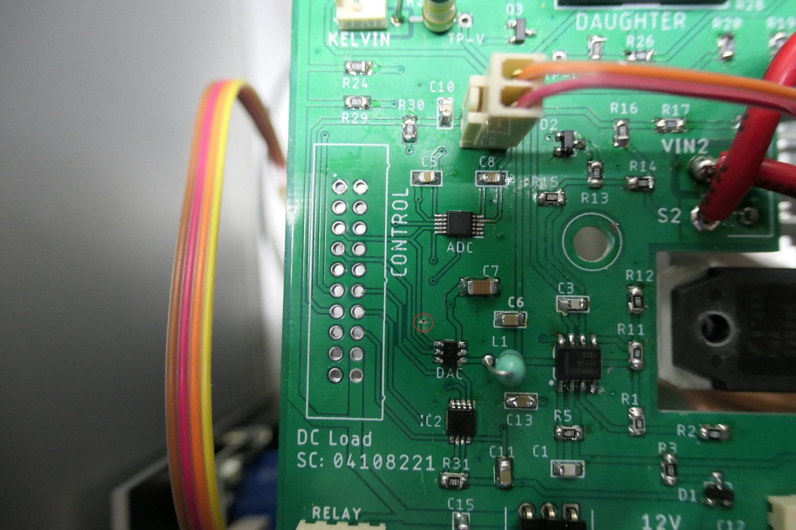
2
1

Regulator orientation is incorrect and heatsink may be required
The 7805 regulator pin markings are reversed on the silkscreen overlay. Input Pin 1 should go to the right, connecting to the 12V input terminals.
The prototype used a VXO7805 switching regulator and no heatsink was specified when the parts list was amended to a 7805 regulator. A small flag heatsink may be required. A ‘touch test” will indicate whether a heatsink is required.

